OVLP/SRP Academic Year 2025-26
Duration: April 13 - 17, 2026 |  |  | Grade: Pre-Nursery |  | Subjects: All
Term III |  | Week: 7
 | English | Urdu |  | Math |  | HCD | IT
Links | class story  The Dark Forest The Little Firefly  https://drive.google.com/file/d/1L9pUorlMogVSLUpbl2MxG3qFKdzqsfCA/view?usp=sharing  The Kind Farmer and the Clever Cow  https://drive.google.com/file/d/1PjpGDXqaMBzFycjlhqpkM_y4mYPm-Kwf/view?usp=sharing  Letter w  https://drive.google.com/file/d/1rsDbaMYKF8gMK4iBqArj5iFxKII1CZw2/view?usp=share_link  Reading Letter w  https://drive.google.com/file/d/1Y8TuqpbI6W18oinE1oxtkuahBuDSoMS0/view?usp=sharing | Class story  Murghi or chiriya  https://drive.google.com/file/d/1l1Gdko6TYpm5cb6e8JHlenTX2PK9_s5h/view?usp=sharing  Bhalu ka bacha  https://drive.google.com/file/d/1ncUv2pL3RmwAOLrY5lHQ84rCgscjfDzj/view?usp=sharing  Ont or Saya  https://drive.google.com/file/d/1kickcOMQo0xpV-bJFEhDATb68gkuEENC/view?usp=sharing  Harf tohen.  https://drive.google.com/file/d/1E4QntBDJmN0kAqANxnrxuzdMPLgVS1sM/view?usp=share_link  Reading Harf tohen.  https://drive.google.com/file/d/1AWMOtt-eUuzGmFnAYU8ghFEXWAud1ULk/view?usp=sharing |  | Number 22.  https://drive.google.com/file/d/1XfHkapST9o0SW11hyabV1Qsa0fFOsQ5v/view?usp=sharing |  | P.N TIIISRP7 | https://silveroaksedupk-my.sharepoint.com/:v:/g/personal/cp_it_soies_co/IQCL78yAsr2XR4SJAaLjzUm5AfihKh6W69ZvESu-6UzrUtM?nav=eyJyZWZlcnJhbEluZm8iOnsicmVmZXJyYWxBcHAiOiJPbmVEcml2ZUZvckJ1c2luZXNzIiwicmVmZXJyYWxBcHBQbGF0Zm9ybSI6IldlYiIsInJlZmVycmFsTW9kZSI6InZpZXciLCJyZWZlcnJhbFZpZXciOiJNeUZpbGVzTGlua0NvcHkifX0&e=O01BgG&referrer=Outlook.Web&referrerScenario=email-linkwithembed
Day 1  C.W | - Writing ‘w’.  - Draw a picture with letter “w” (watch, watermelon).  - Note book pg. # 19 | 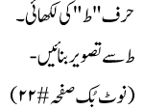 |  | Recognition of number 22 |  | Pupils will learn about Sharing/ Vegetables
Home work | - Writing ‘w’.  - Draw a picture with letter “w” (watch, watermelon).  Note book pg. # 20 | ____________ |  | _____________ |  | --------
Day 2  C.W | Reading letter w. | 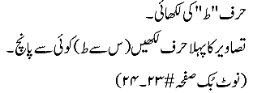 |  | - Write number 22.  - Circle the correct number. (20– 21 – 22 )  - Note book pg. # 16-17 |  | Pupils will learn about “White Butter”.
Home work |  | 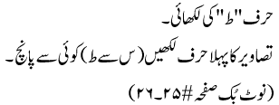 |  | _____________ |  | ---------
Day 3  C.W | - Writing ‘w’.  - Write the first letter of the pictures. (Sparrow, tiger, vegetable, and watch)  - Note book pg. # 21 | 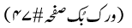 |  | - Write number 22.  - Count and write (20,22)  - Note book pg. # 18 |  | Pupils will be playing Zig Zag races.
Home work | _____________ |  |  | - Write number 22.  - Count and write (20,22)  - Note book pg. # 19 |  | ------------------------
Day 4  C.W | - Write a-w.  - Circle all “w”.  - Note book pg. # 22 | 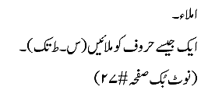 |  | Workbook pg. # (36). |  | Oral Questions and Answers:  Q.1: What is the national language of Pakistan? Ans: Urdu is the national language of Pakistan.  Q.1: Which Dua do we say when we go upstairs. We say “ALLAHU AKBAR” when we go upstairs.  Q.1: Tell the names of 5 vegetables. Ans: Tomato, Potato, Carrot, Radish and Onion.
Home work |  |  |  |  |  | ---------
Day 5  C.W | - Dictation.  - Fill in the blanks. (a –w).  - Note book pg. # 23 | حرف ط کی لکھائی |  | - Dictation.  - Fill in the blanks (10-22).  - Note book pg. # 20 |  | The revision of all the previous work done this week is complete.
Home work |  | Reinforcement |  |  |  | ---------

